Vehicle Weapons
Vehicle Machine Gun, Medium
Skill: P.G.S. Weapons
Cost: 2,000 Credits
Weight: 20 kilograms
Hard Points: 2 (medium)
Rate of Fire: 1 burst
Damage: 15d10
Ammo: 20 bursts (200 rounds)
SEU: N/A
Defense: Inertia
PB: --
Short: 0-150 m
Medium: 151-300 m
Long: 301-750 m
Extreme: 751-1,500 m
Vehicle Machine Gun, Large
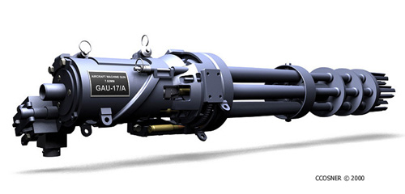
Skill: P.G.S. Weapons
Cost: 4,000 Credits
Weight: 70 kilograms
Hard Points: 4 (large)
Rate of Fire: 1 burst
Damage: 2d10 x 10
Ammo: 30 bursts (300 rounds)
SEU: N/A
Defense: Inertia
PB: --
Short: 0-200 m
Medium: 201-500 m
Long: 501-1,000 m
Extreme: 1,001-2,000 m
These large caliber machine guns have a greater muzzle velocity than a portable machine gun. Baffles surround its barrel so that the muzzle flash is not visible at night.
The large machine gun is more of a Gatling-type gun that uses multiple barrels in a rotating cluster. It provides a rapid rate of fire because the loading, firing and unloading operations occur as the barrels rotate. This rotation also allows the individual barrels to cool, reducing the chances of misfiring. Each barrel fires a single shot when it reaches the firing point in the cycle; then the spent cartridge is ejected followed by a new round being loaded.
Cannon, Small
Skill: Artillery
Cost: 4,000 Credits
Weight: 40 kilograms
Hard Points: 2 (medium)
Rate of Fire: ½
Damage: 8d10
Ammo: 20 shells
SEU: N/A
Defense: Inertia
PB: 0-150
Short: 151-300 m
Medium: 301-600 m
Long: 601-1,000 m
Extreme: 1,001-2,000 m
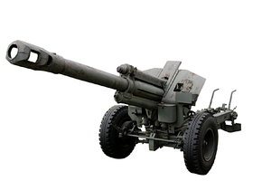
Cannon, Medium
Skill: Artillery
Cost: 6,000 Credits
Weight: 80 kilograms
Hard Points: 4 (large)
Rate of Fire: ½
Damage: 12d10
Ammo: 15 shells
SEU: N/A
Defense: Inertia
PB: 0-300
Short: 301-600 m
Medium: 601-1,200 m
Long: 1,201-2,000 m
Extreme: 2,001-3,000 m
Cannon, Large
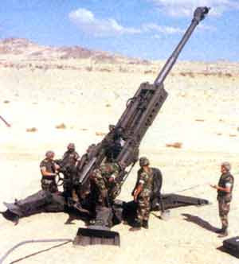
Skill: Artillery
Cost: 10,000 Credits
Weight: 160 kilograms
Hard Points: 8 (large)
Rate of Fire: ½
Damage: 3d10 x 10
Ammo: 10 shells
SEU: N/A
Defense: Inertia
PB: 0-600
Short: 601-1,200 m
Medium: 1,201-2,400 m
Long: 2,401-5,000 m
Extreme: 5,001-10,000 m
Cannons have a single, long barrel and fire single shells at high rates of speed. The impact of the shell is impressive. On smaller vehicles, cannons tend to “rock” the vehicle backward when fired. They are often fired as indirect weapons, but can also be fired directly at a target. If the cannon is too close, it can get damaged or destroyed by its own shell. These weapons can also be fired at aerial targets, but often that requires changing to a different type of ammunition.
Howitzer
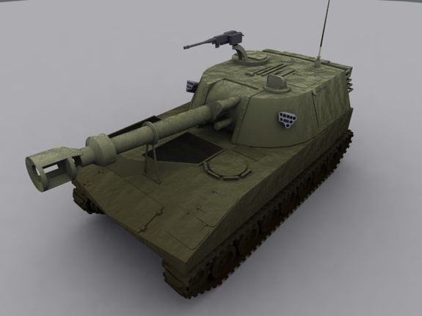
Skill: Artillery
Cost: 25,000 Credits
Weight: 350 kilograms
Hard Points: 10 (large)
Rate of Fire: 1/4
Damage: 7d10x10 + 50
Ammo: 10 shells
SEU: N/A
Defense: Inertia
PB: --
Short: --
Medium: 200-3,000 m
Long: 3,001-7,000 m
Extreme: 7,001-15,000 m
This long range artillery weapon normally will only be encountered when used by planetary militias or large mercenary companies.
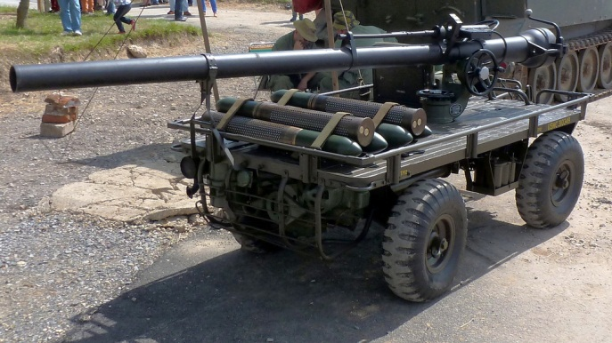
Vehicle Recoilless Rifle
Skill: P.G.S. Weapons
Cost: 5,500 Credits
Weight: 30 kilograms
Hard Points: 2 (medium)
Rate of Fire: 1/2
Damage: 20d10
Ammo: 20 bursts
SEU: N/A
Defense: Inertia
PB: --
Short: 0-200 m
Medium: 201-1,250 m
Long: 1,251-3,000 m
Extreme: 3,001-5,000 m
This is similar to the version in the Star Frontiers Alpha Dawn Expanded Game Rules book, but it has a larger caliber.
Vehicle Rocket Launcher, Medium
Skill: P.G.S. or Missile Weapons
Cost: 6,000 Credits
Weight: 17 kilograms
Hard Points: 2 (medium)
Rate of Fire: ½
Damage: 20d10
Ammo: 1 rocket
SEU: N/A
Defense: Inertia
PB: --
Short: 0-200 m
Medium: 201-500 m
Long: 501-1,000 m
Extreme: 1,001-2,000 m

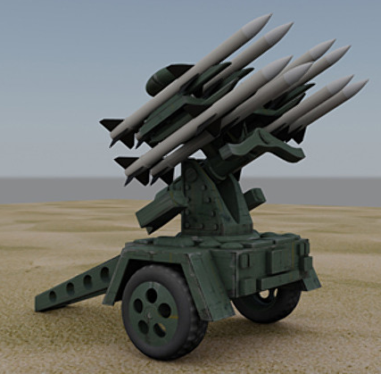
Vehicle Rocket Launcher, Large
Skill: P.G.S. or Missile Weapons
Cost: 8,000 Credits
Weight: 20 kilograms
Hard Points: 2 (medium)
Rate of Fire: ½
Damage: 10d10 x 3
Ammo: 1 rocket
SEU: N/A
Defense: Inertia
PB: --
Short: 0-200 m
Medium: 201-500 m
Long: 501-1,000 m
Extreme: 1,001-2,000 m
Vehicle rocket launchers use longer, larger rockets than the Expanded Game Rules version. Note the different rocket calibers; one vehicle RL cannot fire both. Also note that in jetcopter and aircar weapon pods, the rockets are each mounted in a separate tube; any number of rockets may be fired in a single turn.
Rocket Clusters, small, medium and large
Skill: P.G.S. or Missile or Artillery Weapons
Hard Points: 4 (medium)
Rate of Fire: 1 or all
Small Rocket Cluster
Cost: 5,000 Credits
Weight: kilograms
Damage: normal or 15d10 (area)
Ammo: 12 rockets
Medium Rocket Cluster
Cost: 7,000 Credits
Weight: kilograms
Damage: normal or 3d10 x 10 (area)
Ammo: 6 rockets
Large Rocket Cluster
Cost: 10,000 Credits
Weight: kilograms
Damage: normal or 4d10 x 10 (area)
Ammo: 3 rockets
Similar to the missile launchers detailed in Zebulon’s Guide, vehicle rocket clusters use multiple launchers and can be mounted on vehicles or in pods for air vehicles. The small rockets are the same as those in the Expanded Game Rules, while the medium and large versions use vehicle rockets. They can be fired individually or in two or more increments. The pilot or driver lines up his vehicle to the target – or aims the swivel mount and fires.
These weapons also can be mounted on the backs of trucks or trailers and fired indirectly, but a character needs an artillery skill to use them successfully.
Small Vehicular Flamethrower
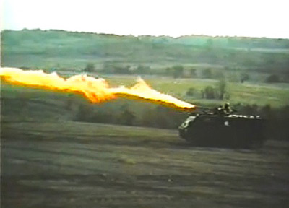
Skill: P.G.S. Weapons
Cost: 1,800 Credits
Weight: 15 kilograms
Hard Points: 2
Rate of Fire: 1
Damage: 4d10+4/special
Ammo: 20 shot tank
SEU: N/A
Defense: Asbestos
PB: --
Short: 0-25 m
Medium: 26-50 m
Long: 51-100 m
Extreme: 101-150 m
Medium Vehicular Flamethrower
Skill: P.G.S. Weapons
Cost: 3,000 Credits
Weight: 40 kilograms
Hard Points: 4
Rate of Fire: 1
Damage: 4d10+4/special
Ammo: 10 shot tank
SEU: N/A
Defense: Asbestos
PB: --
Short: 0-30 m
Medium: 31-60 m
Long: 61-120 m
Extreme: 121-240 m
Vehicle-mounted flamethrowers are used to clear brush – and in times of war, burn out enemy troops from fortified locations. The weapon also poses a danger to the user. If it is shot while facing the front of a vehicle is traveling faster than 40 meters/turn, the flamethrower will subject the vehicle to an attack from its own flame. The fire from a small vehicle-mounted flamethrower will do 1d10 damage/turn to a target for the next five turns after the turn in which it was fired. The flames from a large vehicle-mounted flamethrower will do 1d10 damage/turn to a target for the next eight turns after the turn in which it was fired.
Medium Laser Cannon
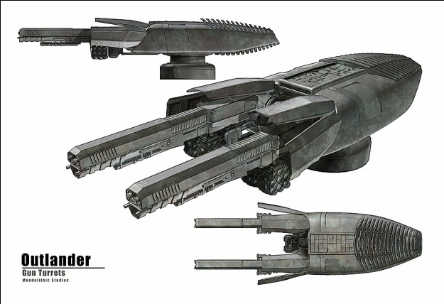
Skill: Beam Weapons
Cost: 9,000 Credits
Weight: 28 kilograms
Hard Points: 2
Rate of Fire: 1
Damage: 2d10+10 per SEU
Ammo: 100 SEU pack or 250 SEU econopack or 1,000 SEU drum
SEU: 10-40
Defense: Albedo
PB: --
Short: 0-150 m
Medium: 151-600 m
Long: 601-1,200 m
Extreme: 1,201-2,500 m
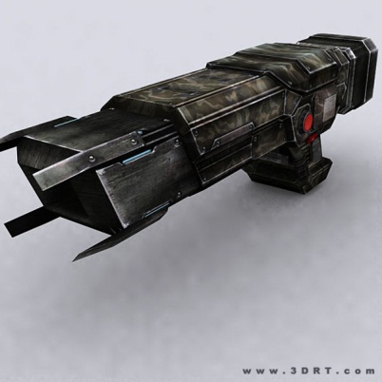
Large Laser Cannon
Skill: Beam Weapons
Cost: 12,000 Credits
Weight: 75 kilograms
Hard Points: 4
Rate of Fire: 1
Damage: 4d10+10 per SEU
Ammo: 250 econopack or 1,000 SEU drum
SEU: 10-60
Defense: Albedo
PB: --
Short: 0-300 m
Medium: 301-1,000 m
Long: 1,001-2,000 m
Extreme: 2,001-4,000 m
Laser cannons fire a destructive, concentrated beam of energy at a target. The beam simply slices through unprotected areas, searing sensitive systems on a target.
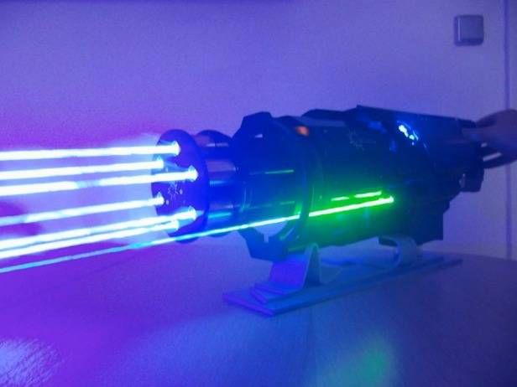
Autolaser
Skill: Beam Weapons
Cost: 3,000 Credits
Weight: 20 kilograms
Hard Points: 1
Rate of Fire: 1
Damage: 10d10/burst
Ammo: 250 econopack or 1,000 SEU drum
SEU: 20/burst
Defense: Albedo
PB: 0-50
Short: 51-100 m
Medium: 101-200 m
Long: 201-400 m
Extreme: 401-1,000 m
Using several barrels, the autolaser can rapidly fire tens of lasers per second as the gunner hopes to catch the target in the burst. The laser itself doesn’t make noise, but the motion of the weapon’s mechanics – similar to a Gatling machine gun – does have a particular whine.
Medium Sonic Cannon (Devastator Mk. II)
Skill: Beam Weapons
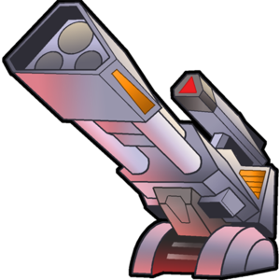
Cost: 8,000 Credits
Weight: 28 kilograms
Hard Points: 2
Rate of Fire: 1
Damage: 20d10+20/15d10+15/ 10d10+10/5d10+5/1d10
Ammo: 100 SEU pack or 250 SEU econopack or 1,000 SEU drum
SEU: 20
Defense: Sonic
PB: 0-10 m
Short: 11-100 m
Medium: 101-200 m
Long: 201-300 m
Extreme: 301-400 m
Large Sonic Cannon (Devastator Mk. III)
Skill: Beam Weapons
Cost: 12,000 Credits
Weight: 65 kilograms
Hard Points: 8
Damage: 30d10+20 / 25d10+15 / 20d10+10 / 15d10+5 / 10d10
Ammo: 250 econopack or 1,000 SEU drum
SEU: 30
Defense: Sonic
PB: 0-20
Short: 21-120 m
Medium: 121-250 m
Long: 251-450 m
Extreme: 451-650 m
While most militaries tend to use kinetic and laser weapons, some mercenary units incorporate sonic weapons into their arsenals. This weapon fires a concentrated beam of chaotic sound that is clearly recognizable as a ball of shimmering air disturbance as it speeds at its target. However, the greater the distance the target is from the weapon, the less damage it does. One major drawback of sonic weapons, however, is they cannot be used in a vacuum and their effectiveness is reduced on planets with a thin atmosphere.
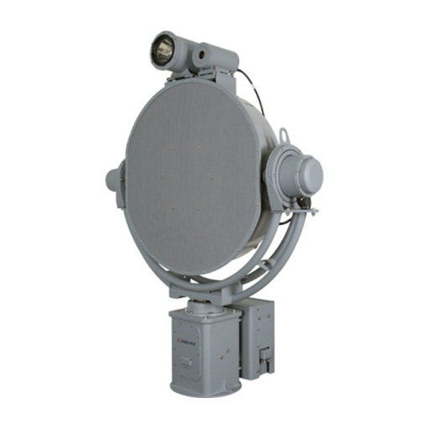
Long Range Acoustic Device (LRAD)
Skill: Beam Weapons
Cost: 4,500 Credits
Weight: 15 kilograms
Hard Points: 1 (small)
Rate of Fire: 1
Damage: Varies
Ammo: 100 SEU pack
SEU: Varies
Defense: Sonic or Sonic/A-S implant
PB: 0-50 m
Short: 51-100 m
Medium: 101-200 m
Long: 201-300 m
Extreme: 301-500 m
The LRAD, also called a sonic stunner cannon, is a bulky police/paramilitary weapon used for crowd control. Often mounted on vehicles, robots, remote sentry units or on a tripod, it is an area effect weapon that can hit all beings within a cone out to its extreme range. It has four settings: Irritation, Stun Level 1, Stun Level 2 and Stun Level 3. Each setting has a different power consumption rate and damage effects.
Setting 1: Irritation is the one most commonly used by law enforcement. It broadcasts a loud, disruptive sound within a 90 degree cone in front of the device with the purpose of trying to coax beings to leave the area. Targets within point black and short range suffer a -20 percent modifier to all skill and ability checks. Targets within medium range suffer a -15 percent penalty; -10 at long range and -5 at extreme range. It hits automatically and consumes 2 SEU per minute of continuous use.
Setting 2: Irritation/Stun still broadcasts a non-lethal irritation sound but it also acts like a sonic stunner. It will only affects targets within a 15-meter-wide cone in front of the device. Use the burst-fire modifiers for determining the chance to hit. Targets must make a successful Stamina check to avoid being stunned (note targets within point black and short range suffer a -20 percent modifier to all skill and ability checks, -15 for targets at medium range, -10 at long range, and -5 at extreme range. It uses 4 SEU per shot.
Setting 3 acts like a sonic stunner but also causes physical damage to targets within a 15 meter wide cone in addition to a stunning effect. Note, a target gets to make a current Stamina check after taking the sonic damage. At point blank and short range, it causes 2d10 of damage; 1d10 damage at medium and long range; but only the stunning effect at extreme range. This setting uses 10 SEU per shot.
Setting 4 causes more damage in addition to a stunning effect. At point blank and short range, targets take 4d10 damage, at medium range, 3d10 damage, at long range, 2d10, and 1d10 at extreme range. This setting uses 15 SEU per shot.
Small Maser Cannon
Skill: Beam Weapons
Cost: 5,000 Credits
Weight: 15 kilograms
Hard Points: 1
Rate of Fire: 1
Damage: 10d10
Ammo: 100 SEU pack
SEU: 10
Defense: MasMesh
PB: 0-15 m
Short: 16-40 m
Medium: 41-100 m
Long: 101-200 m
Extreme: 201-500 m
Masers are amplified microwave emitters that deliver a devastating beam of concentrated energy. It can blind anyone using unshielded high-resolution infrared (IR) goggles and interfere with IR scanners. Maser fire penetrates practically any type of defensive suit or screen except MasMesh or a gridsuit. The small maser cannon is the counterpart of the Ke-5000 Heavy Laser and the Rafflur M-10. Portable versions come equipped with a tripod. Two characters are often needed to transport it and its battery.
WarTech Delta Bolt Cannon
Skill: Beam Weapons
Cost: 9,000 Credits
Weight: 15 kilograms
Hard Points: 1
Rate of Fire: 1
Damage: 2d10 + 10 per SEU
Ammo: 100 SEU pack
SEU: 5-20
Defense: Gridsuit
PB: 0-20 m
Short: 21-60 m
Medium: 61-200 m
Long: 201-500 m
Extreme: 501-800 m
Billed as the “thunderbolt” weapon, WarTech’s Delta Bolt Cannon fires in invisible beam of heavy ions, but this also creates a thunderclap that can be heard up to several kilometers away. This is the only version of WarTech’s bolt weapons that can use a large, purpose-made power pack. It cannot be powered by normal SEU packs or the SEU drum pack, which limits its effectiveness and desirability to special operations types.

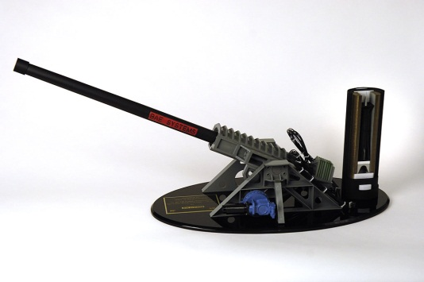
Railgun (Gauss Cannon)
Skill: Beam or Artillery Weapons
Cost: 80,000 Credits
Weight: 500 kilograms
Hard Points: 12
Rate of Fire: 1
Damage: 8d10 x 10
Ammo: 1,000 SEU drum plus 50 rounds
SEU: 20
Defense: Inertia
PB: --
Short: 0-1,000 m
Medium: 1-10 km
Long: 10-150 km
Extreme: 150-350 km
The precursor to portable gauss rifles, the railgun is an artillery weapon that has beam technology characteristics. It uses an electromagnetic launch system instead of gunpowder or a propellant to fire an armor-piercing projectile up to Mach 10. It delivers its munitions with a range and destructive force that far exceeds conventional weapons. Generally this weapon is unavailable except for well-equipped planetary militias, the UPF Landfleet or the richest mega-corporations.
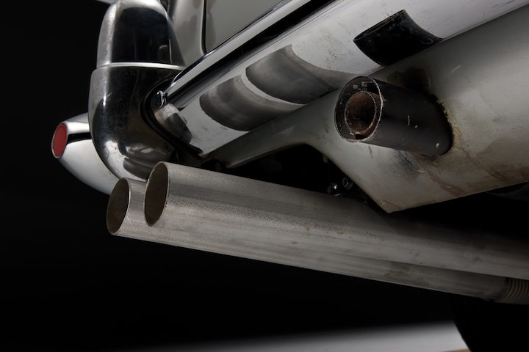
Vehicular Sprayer
Skill: N/A
Cost: 1,000 Credits
Weight: 10 kilograms
Hard Points: 2 (medium)
Rate of Fire: 1
Damage: Varies
Ammo: 10 bursts
SEU: N/A
Defense: Varies
PB: 0-5 m
Short: 6-20 m
Medium: 21-30 m
Long: 31-40 m
Extreme: 41-60 m
The vehicular sprayer is a device used by spies and other nefarious characters. It is not commonly found in the Frontier with the exception of the smoke generator version. The three basic types are the smokescreen generator/sprayer, the paint sprayer and the oil sprayer. Most are designed to expel their substances behind the vehicle so the attacker won’t become enveloped in its own trap.
The smokescreen generator forms smokescreen forms a 50-meter diameter cloud, blocking vision and IR sights but not radar. It lasts 5 turns; any vehicle going through it is sightless for 1 turn. Military units often use vehicles like this to obscure parts of the battlefield from the unaided eye.
Paint sprayers cover an area 10-meters-by-3-meters behind the vehicle with the intention of obscuring the windshield of any following vehicles. Most paints will block vision (but not IR or radar or other sensors) by coating windows. The paint lasts until scrubbed off and will also completely ruin any coats of reflective paint on the target vehicle. It cannot be removed without also removing the reflective paint beneath it.
Oil jets form a 20-meter-by-2-meter slick on the roadway or surface behind them. The driver of a vehicle traveling faster than its turn speed must make a Reaction Speed check or lose control. The driver of an Explorer or similar vehicle has a +20 bonus on the control roll. Hover vehicles are not affected at all. Also, the terrain this oil is sprayed on may nullify or reduce its effects.
Each type of sprayer is a separate weapon, but all are the same size and cost. Also note that sprayers on jetcopters and certain air vehicles will have their jets broken up by the rotor wash, making them ineffective at best.
The dimensions given for oil and paint jets assume that the vehicle is traveling at its turn speed. If the referee wishes the extra work, he can assume that traveling slower widens and shortens the slick, and traveling faster extends and narrows it. No more than 50 percent alteration of either length or width should be allowed.
Sprayer weapons do not require a weapon skill. Add 5 percent per level of the driver’s skill to half of his Dexterity (DEX) score for an attack roll if these weapons are aimed at a pursuer.
Mine Dropper
Skill: N/A
Cost: 750 Credits
Weight: 10 kilograms
Hard Points: 2 (medium)
Rate of Fire: 5 mines
Damage: Varies
Ammo: 10 mines
SEU: N/A
Defense: RS check
PB: N.A.
Short: N.A.
Medium: N.A.
Long: N.A.
Extreme: N.A.
Another weapon that is more from the realm of spies than military use, the mine dropper lays 5 mines on the road behind the vehicle. Distribution is determined by speed and maneuvers during the dropping turn. If any vehicle subsequently passes over them, the mines will detonate on a 50 percent activation roll. The 5d10 damage figure is per mine. This is a generally useless weapon for flying vehicles; the mines spread too much and explode on impact if dropped over 5 meters. Mines from a mine dropper weigh 5 kilograms each.
Bombs
Skill: Dropped Weapons
Small Bomb Medium Bomb
Cost: 100 Credits 250 Credits
Weight: 15 kilograms 30 kilograms
Hard Points: 1 2
Rate of Fire: 1/all 1/all
Damage: 10d10+100 20d10 +200
Ammo: 1 1
SEU: N/A N/A
Defense: Inertia Inertia
PB: 0-10 0-10
Short: 11-30 11-30
Medium: 31-60 31-60.
Long: 61-120 61-120.
Extreme: 121+ 121+
This is a dropped weapon, mounted on jetcopter or aircar pylons. Statistics for light and medium bombs are given. These are “dumb” bombs and are not very sophisticated and are indicative of those used during Laco’s War and other corporate war conflicts.

