THE LURKER ABOVE
By Laura Mumma, Tchklinxa

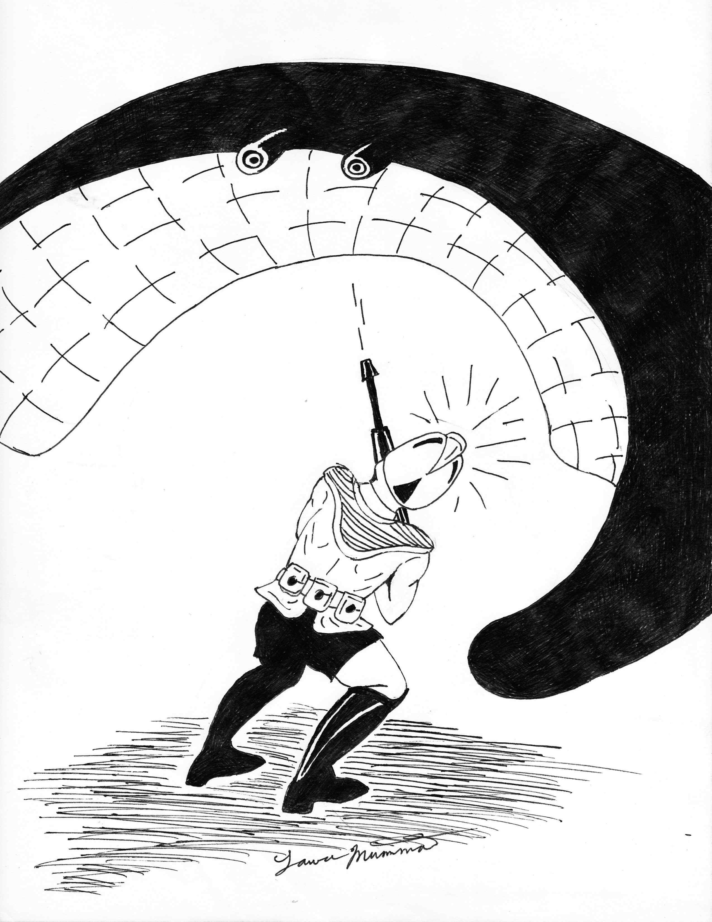

The Lurker Above creature first appeared in The Strategic Review #3 August 1975, first edition Advanced Dungeons & Dragons original Monster Manual 1977 by Gary Gygax, and was an alien creature introduced to AD&D from a crashed space ship in Module S3 Expedition to the Barrier Peaks by Gary Gygax published 1980 but was originally a 1976 Origins II tournament scenario. What this all means for referees and the Star Frontiers setting is The Lurker Above is really an alien creature from an unknown planet. In my setting when an alien ship crashed on Yaziria the creature became naturalized; Yazirians thus believe it is a native creature; actual planet of origin unknown.

TYPE: Giant Carnivore
NUMBER: 1-4
MOVE: Very Slow 1.5 meters/13.5 meters
IM/RS: 2/20
STAMINA: 85
ATTACK: 75
# of Attacks: 1
DAMAGE: 1d10 Constriction
SPECIAL ATTACKS: Smothers
SPECIAL DEFENSES: Camouflage/silent movement
NATIVE WORLD: Unknown
Habitat: caves, caverns, tunnels.

DESCRIPTION:

This terrible beast somewhat resembles a large manta ray. Its grayish belly is so textured as to appear to be stone, and the Lurker typically attaches itself to a ceiling where it is almost impossible to detect (PCs have only a 10% chance to detect it by eyesight alone) unless actually prodded. In a large chamber there maybe as many as 4 of them, but normally only one is encountered. The Lurker can creep along surfaces but very slowly. They move about by means of a gas, which makes them neutrally buoyant, and a flapping of their wing like appendages, which can be over 6 meters tip to tip. Size of this creature varies by its age from 1 to over 6 meters. Generally PCs will be attacked by a Large to Giant Lurker, though a Lurker as small as 2 meters can easily attack an individual human sized or smaller PC. Lurkers can attack multiple victims at once if large enough, a 1 meter sized Lurker can still kill if it engulfs the head of it’s victim. Despite the creatures potential full-grown size and strength it is very light weight. They are a stealth predator and surprise their prey all INT rolls to detect them receive a -30 modifier. When disturbed the Lurker drops from the ceiling, smothering all creatures beneath in the tough folds of its “wings.” This constriction causes 1d10 STA damage per turn, and the victims will smother in 2-5 turns in any event unless they kill the Lurker and thus break free. Unintelligent, the Lurker will fight until dead. Prey caught in its grip cannot fight unless the weapons used are both short and in hand at the time the creature falls upon them. The female Lurker lays glutinous sacks of eggs on the ground, and newborns feed upon vermin that can be found on cave floors.

This creature though dangerous to pursue have a hide that became prized by Yazirians for a variety of uses.

