Mirror Plant:

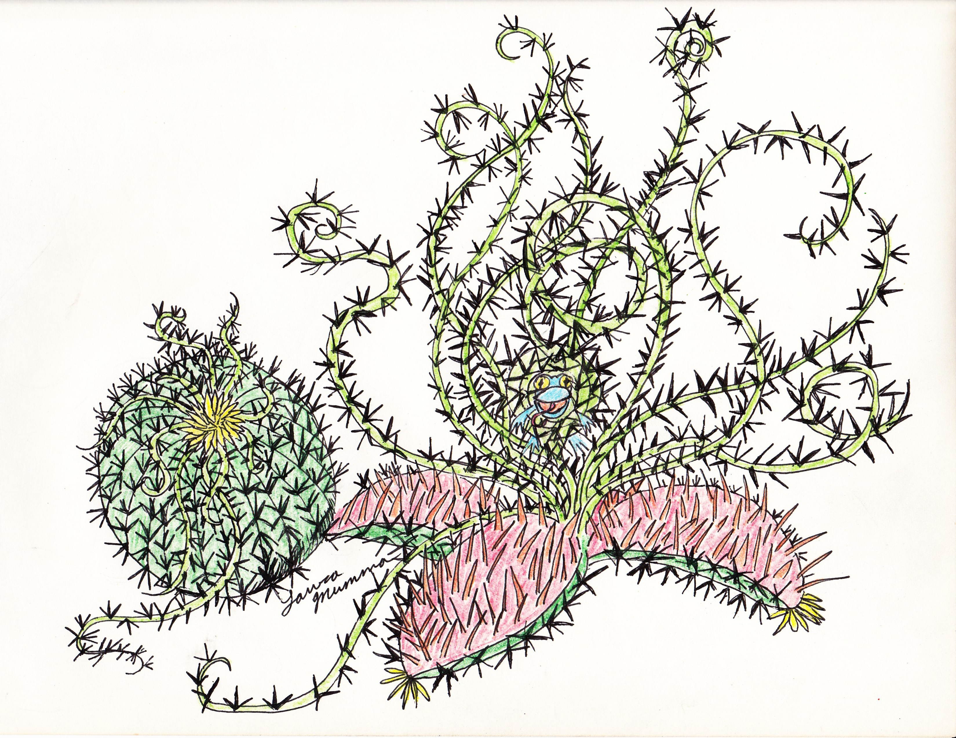

The Mirror Plant appeared in “The Trouble On Janus” module by Robert Jennings at the Massconfusion 1984 Star frontiers Competition.

Type: Medium, standing about 2 meters tall, 1 ½ meters thick
Number Appearing: 1
Move: stationary, see below
IM/RS: 7/65
STA: 400
Attack: 10 tentacles 60%, range up to 15 meters, tentacles are withdrawn into plant for most of length when not attacking.
Number of Attacks: See special, then 1 each per tentacle, tentacles are fast able to shoot out 15 meters in 1 turn and will pull a victim caught in them into its mouth in the next turn if victim does not free themselves or is freed by others.
Damage: ½ D10 per tentacle, thorns along tentacle, mouth does 20 D10
Special Attacks/Defenses: Plant attacks with a flash of light, 50% chance victim will be stunned or disorientated for ½ D10 turns. Plant can flash once every 20 turns, 3 times per day, will use all charges up if heavily damaged. Plant also casts a direct mirror image of itself as soon as it takes any damage. This duplicate appears between ½ to 1 meter to the right of the plant and is a mirror image of it, caused by release of vapor and humming sound to cause partial hypnotic effect on victims or anyone else within 33.5-meter radius.
Native World: Janus
Habitat: Jungle

Mirror plants do not need to eat often and are sacred to Woolie tribes. Mirror plants are large fat green plants, sort of like an enormous barrel cactus with yellow flowers and thin tendrils drooping down from its top. The barrel section of the plant can open up, splitting from the top into four parts, revealing a gapping opening lined with long sharp thorn-teeth. When a victim is tossed into the mouth or pulled into the mouth of the plant the plant snaps the four sections closed with extreme force, piercing the flesh and snapping audibly snapping bones of its victims. Note mirror plants seem to be able to learn to a certain degree, such as certain chants mean dinner. Woolie holy people seem to be able to communicate with them, or at least claim they can. Mirror plants are intelligent on some level.

