Janus Wallaby:
Created by Laura Mumma, Tchklinxa 2015
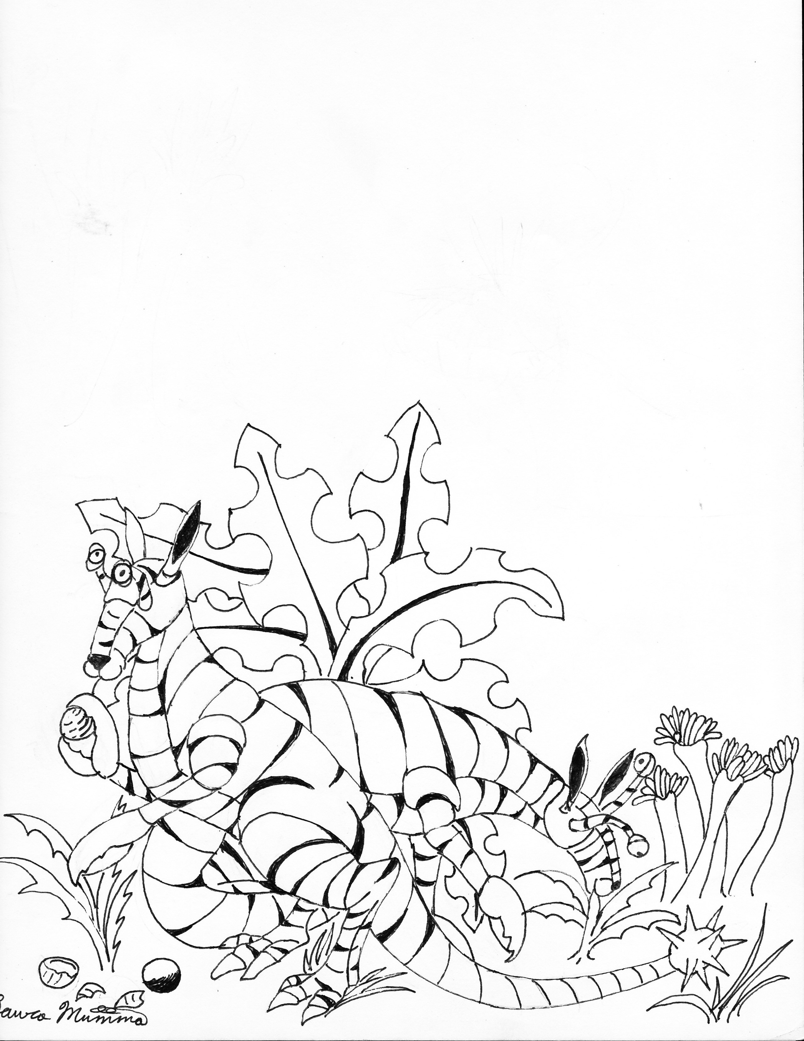

Type: medium herbivores (1.8 meters from head to tip of tail, weight 24 kg.)
Number appearing: 1-100
Move: fast (90 meters/turn)
IM/RS: 7/65
STA: 150
Attack: 45
Number of Attacks: 2
Damage: Stampede strike 2d10, Leap Kick 3d10, Bite 1d10, claws 3d10, tail strike 4d10
Special: Can leap 5 meters, immune to beam weapons.
Native World: Janus
Habitat: Forest, Mountains, Plains

Janus Wallabies have a purple and maroon stripped natural body armor that is segmented (makes them look like a cross between an armadillo and a wallaby) and immune to beam weapons, short forelimbs that end in viscous lobster like claws evolved for cracking into hard husked large nuts, their eyes are on stalks they can swivel around, their legs are very strong, their tail ends in a spiked club that they can strike with as well. Mobs typically stampede through and away from threats, but if cornered or attacked the mob will also form a circle around their young and launch leaping and spinning strikes aimed at the threat or a portion of the adults will break off and attack back giving the mob with juveniles a chance to flee. Once they have the attacker knocked down they will mob their victim pounding it with their legs, clubbed tail and using their claws and teeth to tear the threat apart. Janus Wallabies can not climb, they can leap up but will only do so on boulders, branches or logs that will give them landing support.

