Glass Plasm

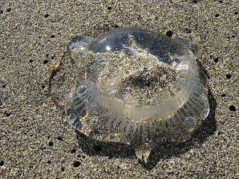

Type: Medium Omnivore
Number: 1 (1)
Move: Slow: 15 meters (5 meters)
IM/RS: 6/55
STA: 65 to 105
Attacks: 1
Attack: 65
Damage: see below

As dangerous as it is unusual, the glass plasm is a crystal-clear protoplasmic blob. A glass plasm moves and attacks much like a grey ooze, lashing out like a snake with a long tendril. If a successful hit is made, the glass plasm will ensnare its victim, attempting to drag him into its mass by sending out another 1-2 more tendrils for this purpose.

If a victim is dragged into a glass plasm and engulfed, it will begin feeding much like a green slime, doing 1d5 points of damage for 8 rounds. If the victim is not freed by then, they should be considered lost and unrecoverable. The glass plasm digests all organic tissue and adds it to its mass within 1d10 rounds of the victim's death. Since a glass plasm cannot digest metal or stone, it expels any indigestible materials rather than letting it “float” within.

Smaller glass plasms are around 1 to 2 meters across and about 15 cm deep. Larger glass plasms can be up to 5 meters across and up to a meter deep. All glass plasms are especially vulnerable to fire and electrical attacks and take half damage from edged weapons.

Because a glass plasm is virtually clear and colorless, it appears as ordinary water when it remains motionless. One tactic a glass plasm will use is to flow into a small depression or culvert, appearing at first glance to be nothing more than a small puddle or pond. If an animal passes nearby (or attempts to wade through it or take a drink), the glass plasm will attack.

A wise adventurer should be wary of any water source that appears oddly clear throughout, since there will not be any sediment floating within as well as no surface debris floating on top. It will also be devoid of fish, frogs, or nearby wildlife. Rather than a refreshing drink, death lies under the surface.

Mutations: chameleon epidermis (special), toxic weapon

(Converted to Star Frontiers Gamma Dawn by Laura Mumma from The Savage AfterWorld Blog by Tim Snider)

(http://savageafterworld.blogspot.com/2009/07/savage-menagerie-glass-plasm.html)

