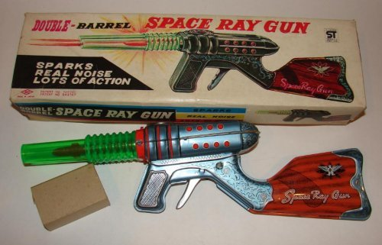
FUSION RIFLE:
Maximum Range: 700 meters
Effective Range: 350 meters
Projectile: 2 beams of intensity
Damage Inflicted: -30/R30! Radiation
Power Source: Atomic Energy Cell
Battery Life: 10 shots
This rifle must be connected to converter by 1.5 meter cable. The converter and the atomic energy cell are both carried in a special pack which fits on the user’s (provided he is reasonably human in shape) back.

Short Range: 175, Medium Range: 350, Long Range: 525, and Extreme Range: 700 meters.

