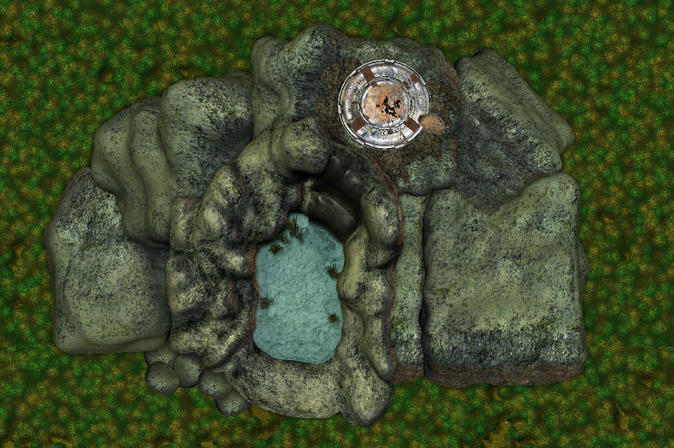
Eorna Defense Installation-Ruins
High atop a cliff in the Bachanda Forest region of Volturnus sits the ruins of an Eorna defense installation which was destroyed by the Sathar during the Day of Doom over 900 years ago. The installation served as a planetary defense battery capable of firing on enemy ships in orbit. As several Sathar ships were destroyed by the battery, it's destruction became a high priority for the invading forces. The roof of the installation took several direct hits from Sathar assault fighters and was destroyed.

Background:
This encounter location is meant to take place during the Volturnus series module SF:1 Volturnus, Planet of Mystery. Ideally, it can be used once the PC's obtain the jetcopter from the pirate outpost and are heading toward Slave City One. Although it is an written as an encounter to leave a few clues for the PC's as to the nature of the Eorna and the Day of Doom, it can be adapted to any campaign setting as a ruined outpost.

Originally, the installation consisted of a planetary defense battery that sat on top of the cliff and two lower levels (barracks and entrance) inside the rock of the cliff that were accessed by a lift. The main entrance of the facility is through a cave opening behind the waterfall, where small Eorna craft could fly in and land.

The Sathar attack on the facility almost completely destroyed the top (battery) level and caused a structural collapse which completely filled the second level (barracks), the lift and shaft with debris. The entrance level was less damaged, but in the years following the Sathar attack the level was stripped of any useful items and technology by the Eorna.
Installation profile view

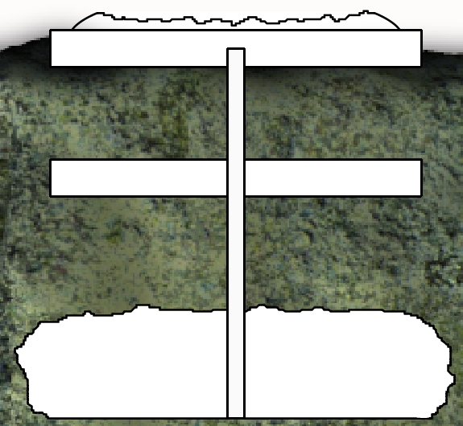
Level 2 –
Collapsed Living Area
Level 2 –
Collapsed Living Area
Level 1 –
Destroyed Battery
Level 3 –
Hidden Entrance
Collapsed Lift Shaft
As seen in the profile view – the main battery is on the surface, with the lift descending 50 meters to the destroyed barracks level. The floor of the entrance level is 75 meters below the second level or 125 meters from the top of the cliff. The height of the cave opening in the cliff is 35 meters.

The only areas that can be accessed are:

The top level can currently be entered through a hole that was blown in the side by a rocket hit. The spaces that can still be explored are detailed in the map legend section.

The entrance level can be accessed either by the party's jetcopter or by scaling down the cliff from the top. The entrance and the interior are detailed in the map legend section.
Additional Notes:
This location includes provisions for two separate scenarios:
In the first scenario, the Eorna installation was destroyed during the Sathar attack, and in the subsequent years, the entrance level was salvaged by the surviving Eorna for equipment and technology that was brought to Volkos to assist in their Great Mission. In this version, the level is empty with the exception of the debris from the collapse of the lift shaft and parts of the cavern ceiling.

In the second scenario, the entrance level of the installation was occupied years later by a lone Eorna scientist who did not agree with the Great Mission. He felt that it would be more effective to develop their existing technology to create sentient machines, which became the Mechanon. This storyline takes artistic license with the canon material and is optional. The storyline is covered in detail on the Starfrontiers.us site in the Volturnus Revisited project.

In both scenarios, the material will be the same, with the exception of the description of the third level. Further details will be given there.

Encounters:
At GM discretion, random encounters can be placed outside the facility, in the ruins of the first and third levels. Note that is the optional scenario is used, there are planned encounters.

ENCOUNTER TABLE GOES HERE

Level One – Destroyed Battery
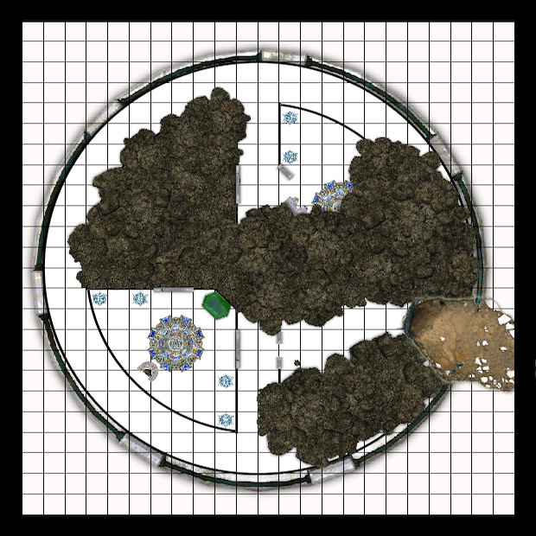
1
1
2
3
5
1 Square = 2 meters
4
Notes on Level 1:
The power to the installation was knocked offline by the Sathar attack. Therefore, there is no power to the installation so none of the equipment, lighting doors, etc. will function. Any use of explosives inside the battery level may dangerously affect the remaining structure, causing a chance of collapse.

1. Entrance
The perimeter wall of the battery was blown open by a Sathar rocket attack. The damage blew a hole through the wall over 4 meters wide. Characters can easily enter the opening in the wall by climbing the debris pile and crouching down to avoid the jagged rocks and metal protruding from the edges of the hole.
2. Partially collapsed chamber
This room is partially filled with rubble – metal, stone, remains of conduit, wiring, etc. as a result of the structural collapse. The rubble fills the sides of the room, but there is a path down the center that will allow the characters to pick their way through to the doors leading to the hallway. The doors are open about a meter wide, obviously blocked open at the bottom by debris at the time of the collapse.

3. Control room
The doors to this room are closed. With the power offline in the installation, the doors will have to be forcibly opened. A torch will open the doors without any issue, as will a prybar. Any attempts at using explosives of any kind have a chance of collapsing the area.

Description:
As you open the doors, the stale air coming from within the room overwhelms your senses. This place has obviously been sealed off for a long time. The room is almost untouched by the collapse seen so far. For some reason, the ceiling has seemed to hold in this area – a very small amount of debris can be seen inside. In the center of the room is a strange looking circular console and a with a seat facing the corner to the right of the door. Along two of the walls are strange clear crystals about a meter high. In the corner near the center of the level is a cabinet of some sort.

This room was used as a gunner's station for the defense battery. The weapon was controlled from the console by sitting on the bench in front of it. The cabinet in the corner houses computer equipment and a large display monitor which are no longer functioning. The four crystals provided light to the room when the installation still had power.

Any examination of the console will reveal that the surface of the console is severely scorched. There are scorch marks on the floor below the bench as well. The Eorna manning this position was killed by a power overload at the console when the installation was hit. On the floor next to the bench are the skeletal remains of the unfortunate gunner mixed with small, fragile scraps of his rotting clothing. The characters will notice that it's skull does not look like any of the intelligent species they have yet discovered on Volturnus. The cabinet in the corner appears similarly scorched. Any technician character examining this equipment may ascertain it's purpose, that it was completely fused and destroyed by a heavy power surge, and that it is a level of technology that seems both advanced and ancient.

4. Partially collapsed hallway
The perimeter hallway has debris along the wall shared with the collapsed northeastern room. The characters should have no problem passing through the area. If the referee elects to have an encounter in the open room at area 5, the PC's might be able to detect tracks or other evidence that they are not alone in the area.

5. Partially collapsed control room
This room was another gunner's station, which was partially collapsed in the attack. One of the doors was ripped off and partially buried under the rubble. The console is also mostly buried. Digging through the rubble by the console will reveal another Eorna skeleton. The referee may elect to have a creature encounter here, as this room is open to the outside and could serve as a den or lair to one of Volturnus' inhabitants.

Level Three (a)– Abandoned Entrance First Scenario:
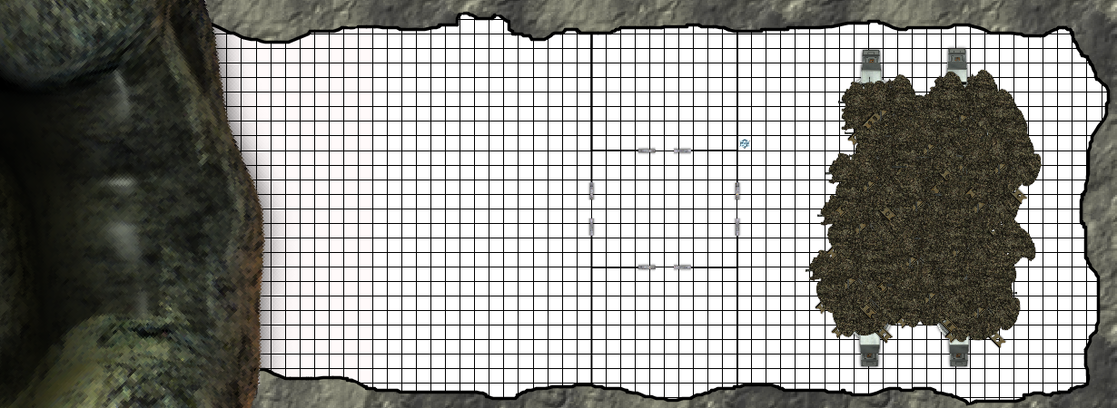
1
2
4
3
5
6
1 Square = 2 meters
Notes on Level 3 (a):
The collapse of the second level and lift shaft caused a partial collapse of the ceiling in the engineering area of the third level. The Eorna subsequently removed the undamaged power reactors and computer equipment and returned it to Volkos. The entire level has been obviously picked through for salvage, although some evidence of the Eorna can been seen in the debris.

1. Secret waterfall entrance
125 meters from the top of the cliff is a cave opening concealed from the outside by the waterfall. It is not easily visible from the air, as the cool water and mist interferes with IR detection devices. Additionally, the waterfall obscures the opening from a distance, but is not so large that it completely blocks it from view. It is visible to characters who are actively searching for it from the pool at the bottom, the top of the cliff, or within 200-300 meters from the air.

The rough entrance is approximately 46 meters wide and 35 meters high. The jetcopter captured from the pirate outpost could land inside the cave provided the pilot does not try to hover under the falling water before the opening. The GM may require a skill check to safely do so.

2. Landing area
The walls and ceiling are rough and vary slightly in dimension, but the floor throughout the level has obviously been made level and flat by some sort of artificial means. There are large scratches in the rock floor throughout this area from the many takeoffs and landings of air and spacecraft in this area. The air inside this area is damp from the mist created by the repeated action of the water against the rock. The GM may elect to have an encounter with some type of mold or slime type of creature.

Party members will see some shattered crystal shards amid the rock, dust and debris on the floor. They may also find bits of tubing and strange wiring of strange metal alloys from the removal of the various pieces of equipment that had once been here.

3. Storage Room
The dust in this room is very thick. It has apparently only been disturbed by small creatures for a long time. Characters may find debris matching the description of area 2, above.

4. Hallway
The doors are all stuck open throughout the level. If the PCs examine them, they show evidence of having been pried open.

5. Storage Room
This room matched the description of area 3, above.

6. Engineering
This large room has suffered a partial collapse. The force of the second level and lift collapse carried into sections of this cavern. The walls of the lift shaft along with all of the supporting structure and power lines going through it collapsed throughout the center of the cavern and took a part of the rock ceiling with it.

The resulting damage destroyed and buried 4 large power reactors. There were other reactors here as well, and characters searching through the area may notice that there was other equipment here that has long since been removed. Bent and torn conduit and shattered crystal shards are throughout the debris area. There is also a damaged crystalline light near the door. It has taken some damage and has several cracks in it.

Parts of the buried reactors can still be seen, and it can also be seen that panels on the equipment have been opened and components removed. A tech character would recognize that the technology is the same as in the first level old, yet advanced. It obviously uses some form of crystalline circuitry.

Level Three (b)– Abandoned Entrance Second Scenario:
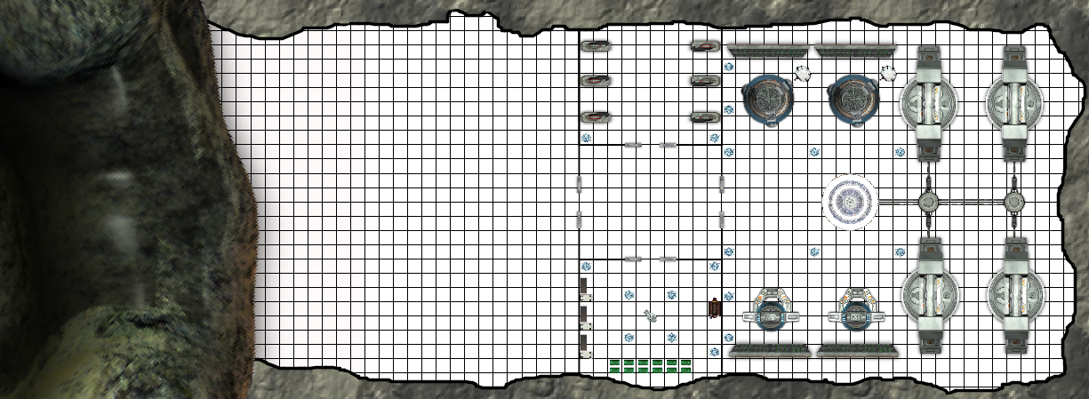
2
3
4
5
6
1 Square = 2 meters
1
Notes on Level 3 (b):
The collapse of the second level and lift shaft caused a partial collapse of the ceiling in the engineering area of the third level. The Eorna maintenance robots, unaffected by the strikes to the defense batteries atop the cliff immediately began clearing obstructions and restoring backup power to the installation. The robots were able to able to bring one of the reactors back online before emergency power failed. Once the robots accomplished this task, they began clearing debris and continuing repairs. The process was coordinated through the main computer, which was protected from the attack. The Sathar, unaware of the location of the entrance, assumed the installation destroyed and left it alone after they defeated the Eorna.

Years later, after the surviving Eorna created their Great Mission, a young Eorna scientist, Anon, decided to go another way. After openly disagreeing with the council of elders, he presented a plan to make advanced robots to combat the Sathar. He was denied and told to spend his efforts assisting the great mission. Convinced the leadership were in great error, he waited, and formulated a plan. He suspected that the secret entrance level of the bombed out installation in the Bachanda forest may still be intact. He thought that if the Sathar couldn't see it behind the waterfall, it could have been untouched. When he arrived, he took control of the computer and robots, and set them to work building his dream – a lab in which he could work on designing the ultimate sentient machine.
Anon began designing the perfect killing machine – a champion to save his race from the Sathar. His intense devotion to save his people combined with the sorrow of the great loss felt by all Eorna slowly eroded his sanity. In the beginning, Anon was consumed by the thought of saving his race, and being proved right. Over the years in isolation he focused less on saving his race, and more on being proved right. He decided to document his work with a video log. Over the centuries the data began to be corrupted, but log several entries survive, detailing Anon's descent into complete madness.

In time, Anon achieved success in creating the Mechanon. He ended up moving his operation to the Mechanon mound location to begin a new phase of his work: the uploading of his mind to the computer there. As he left the installation, he left his log, and some pre-sentient robots that he had developed as prototypes to defend the site...

Planned Encounters:
There are three Mechanon prototypes on this level. They are similar in appearance to the Mechanon, but are not as advanced. They act as level 5 robots. At the referee's discretion, the number can be adjusted up or down to better suit the strength of the party. They work to maintain the facility, and also defend it against unauthorized visitors. They will attack the party on sight.

Mechanon Prototypes:
MV 60m; IM/RS 9/90; STA 130; ATT 80; 2-20 melee or by special attack as listed:

Prototype #1 SA – Electric shock emitters: it's hands produce an electric charge (treat as an electrostunner for damage and range)
Prototype #2 SA – Sonic Blast emitters: hands produce sonic energy (treat as sonic disruptor)

Prototype #3 SA – Laser Blast emitters: (treat as 4 SEU laser pistol)

If the party enter the facility with the pirate jetcopter, at least one prototype will be in area 2. with the others arriving within a few rounds. If the party enters by climbing, the prototypes will be in other areas of the facility.

1. Secret waterfall entrance
The physical description of this area is identical to the description in the section Level Three (a)– Abandoned Entrance First Scenario, above.

2. Landing area
The walls and ceiling are rough and vary slightly in dimension, but the floor throughout the level has obviously been made level and flat by some sort of artificial means. There are large scratches in the rock floor throughout this area from the many takeoffs and landings of air and spacecraft in this area. The air inside this area is damp from the mist created by the repeated action of the water against the rock.

If the party enter the facility with the pirate jetcopter, at least one prototype will be in area 2. with the others arriving within a few rounds.

3. Robot Charging Stations
This room contains 6 strange looking devices – metal with crystalline circuitry. Tin the corners are large crystal structures that provide light to the room. The devices are recharging stations for the robots that used to be here and the prototypes that currently guard the facility. If the party entered the facility quietly, a prototype will be in this area.

4. Hallway
The hallway is empty with heavy sliding metal doors to each area. None of the doors are locked and can be opened by pressing a panel beside the door.

5. Lab
This area was where Anon slept and did a lot of his design work. The room has three workbenches on the west wall from which most of the tools have been taken. In the center of the room is a strange chair that looks like a cross between an exam table and a workbench. The exam chair is surrounded by crystals that light the room. There is a bed on the east wall of the room. Along the south wall are stacks of crates, most of which are empty, but some contain ore, crystals, wire, and other miscellaneous components for Anon's experiments. If the party entered the facility quietly, a prototype will be in this area.

6. Engineering
This large room is the engineering section for the installation. If the party entered the facility quietly, a prototype will be in this area. The main computer is now only partially functional due to centuries of sitting idle. The programming that controls the reactors is still online, but the programs that operate the other machinery in the room are now corrupted and offline. The reactors fill the east end of the large chamber. The computer terminal is in the center of the room, surrounded by lighting crystals. The northwest and southwest corners have strange machines and displays that were once used to manipulate the robots but are now offline. On the computer terminal is a data pad that is resting atop a series of small crystals that act as charging points for the pad. There are three entries on the pad that have not been corrupted. A polyvox is necessary to translate the entries.

Entry #1 shows Anon in his younger years. The log entries show him working in the lab. He says, “The fools would not listen to reason. Their creatures will be too weak to defeat the Sathar. My killing machines will save our people. The tragedy that struck us on the day of doom will not be repeated.”
Entry #2 shows Anon quite a bit older. A Mechanon is in the lab in the exam chair. “After years of experimenting, I have finally achieved true artificial intelligence. I told the council this day would come. They wouldn't listen! I knew I would prove myself smarter than they are. I knew I would beat them!” He then activates the Mechanon, who begins to stand up.

Entry #3 shows Anon very old now. The image is fuzzy and garbled at some points. “Work must continue. I've worn out this body. I still need to show them I was right. I'm going to connect my mind to the mound computer so I can finish my work. Then we nonbiologicals will prevail!!!”

