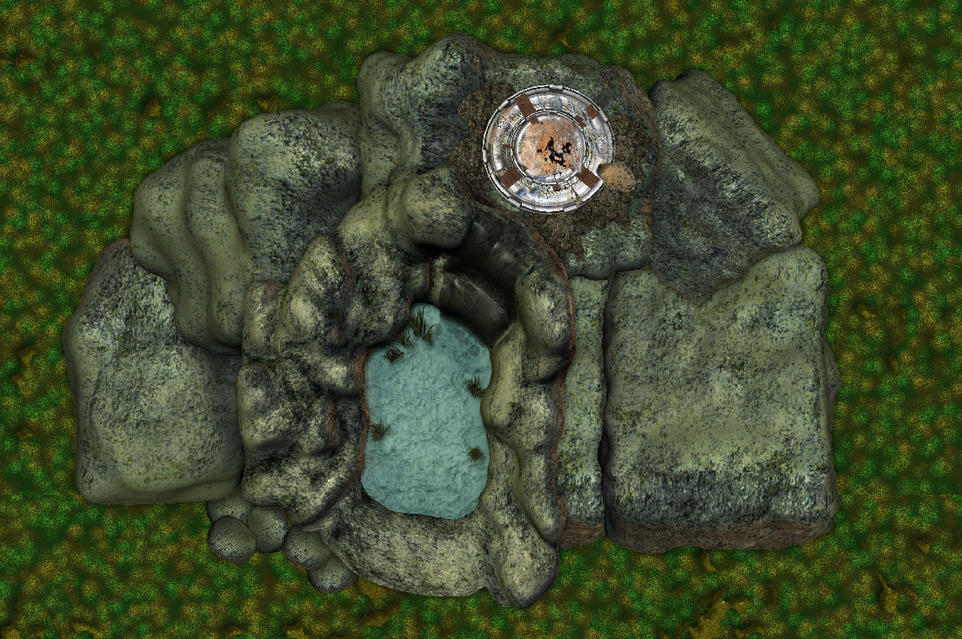
Eorna Defense Installation-Ruins
High atop a cliff in the Bachanda Forest region of Volturnus sits the ruins of an Eorna defense installation which was destroyed by the Sathar during the Day of Doom over 900 years ago. The installation served as a planetary defense battery capable of firing on enemy ships in orbit. As several Sathar ships were destroyed by the battery, it's destruction became a high priority for the invading forces. The roof of the installation took several direct hits from Sathar assault fighters and was destroyed.

Background:
This encounter location is meant to take place during the Volturnus series module SF:1 Volturnus, Planet of Mystery. Ideally, it can be used once the PC's obtain the jetcopter from the pirate outpost and are heading toward Slave City One. Although it is an written as an encounter to leave a few clues for the PC's as to the nature of the Eorna and the Day of Doom, it can be adapted to any campaign setting as a ruined outpost.

Originally, the installation consisted of a planetary defense battery that sat on top of the cliff and two lower levels (barracks and entrance) inside the rock of the cliff that were accessed by a lift. The main entrance of the facility is through a cave opening behind the waterfall, where small Eorna craft could fly in and land.

The Sathar attack on the facility almost completely destroyed the top (battery) level and caused a structural collapse which completely filled the second level (barracks), the lift and shaft with debris. The entrance level was less damaged, but in the years following the Sathar attack the level was stripped of any useful items and technology by the Eorna.
Installation profile view

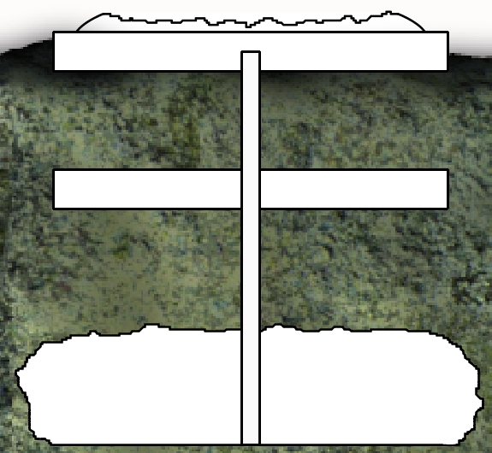
Level 2 –
Collapsed Living Area
Level 2 –
Collapsed Living Area
Level 1 –
Destroyed Battery
Level 3 –
Hidden Entrance
Collapsed Lift Shaft
As seen in the profile view – the main battery is on the surface, with the lift descending 50 meters to the destroyed barracks level. The floor of the entrance level is 75 meters below the second level or 125 meters from the top of the cliff. The height of the cave opening in the cliff is 35 meters.

The only areas that can be accessed are:

The top level can currently be entered through a hole that was blown in the side by a rocket hit. The spaces that can still be explored are detailed in the map legend section.

The entrance level can be accessed either by the party's jetcopter or by scaling down the cliff from the top. The entrance and the interior are detailed in the map legend section.
Level One – Destroyed Battery
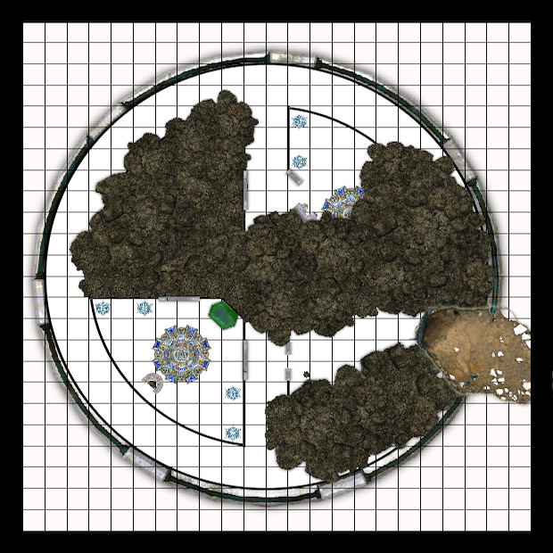
1
1
2
3
5
1 Square = 2 meters
4
Notes on Level 1:
The power to the installation was knocked offline by the Sathar attack. Any useful equipment has long since been salvaged by the Eorna. Therefore, there is no power to the installation so none of the equipment, lighting doors, etc. will function. Any use of explosives inside the battery level may dangerously affect the remaining structure, causing a chance of collapse.

1. Entrance
The perimeter wall of the battery was blown open by a Sathar rocket attack. The damage blew a hole through the wall over 4 meters wide. Characters can easily enter the opening in the wall by climbing the debris pile and crouching down to avoid the jagged rocks and metal protruding from the edges of the hole.
2. Partially collapsed chamber
This room is partially filled with rubble – metal, stone, remains of conduit, wiring, etc. as a result of the structural collapse. The rubble fills the sides of the room, but there is a path down the center that will allow the characters to pick their way through to the doors leading to the hallway. The doors are open about a meter wide, obviously blocked open at the bottom by debris at the time of the collapse.

3. Control room
The doors to this room are closed. With the power offline in the installation, the doors will have to be forcibly opened. A torch will open the doors without any issue, as will a prybar. Any attempts at using explosives of any kind have a chance of collapsing the area.

Description:
As you open the doors, the stale air coming from within the room overwhelms your senses. This place has obviously been sealed off for a long time. The room is almost untouched by the collapse seen so far. For some reason, the ceiling has seemed to hold in this area – a very small amount of debris can be seen inside. In the center of the room is a strange looking circular console and a with a seat facing the corner to the right of the door. Along two of the walls are strange clear crystals about a meter high. In the corner near the center of the level is a cabinet of some sort.

This room was used as a gunner's station for the defense battery. The weapon was controlled from the console by sitting on the bench in front of it. The cabinet in the corner houses computer equipment and a large display monitor which are no longer functioning. The four crystals provided light to the room when the installation still had power.

Any examination of the console will reveal that the surface of the console is severely scorched. There are scorch marks on the floor below the bench as well. The eorna manning this position was killed by a power overload at the console when the installation was hit. On the floor next to the bench are the skeletal remains of the unfortunate gunner mixed with small, fragile scraps of his rotting clothing. The characters will notice that it's skull does not look like any of the intelligent species they have yet discovered on Volturnus. The cabinet in the corner appears similarly scorched. Any technician character examining this equipment may ascertain it's purpose, that it was completely fused and destroyed by a heavy power surge, and that it is a level of technology that seems both advanced and ancient.

4. Partially collapsed hallway
The perimeter hallway has debris along the wall shared with the collapsed northeastern room. The characters should have no problem passing through the area. If the referee elects to have an encounter in the open room at area 5, the PC's might be able to detect tracks or other evidence that they are not alone in the area.

5. Partially collapsed control room
This room was another gunner's station, which was partially collapsed in the attack. One of the doors was ripped off and partially buried under the rubble. The console is also mostly buried. Digging through the rubble by the console will reveal another Eorna skeleton. The referee may elect to have a creature encounter here, as this room is open to the outside and could serve as a den or lair to one of Volturnus' inhabitants.

Level Three – Abandoned Entrance
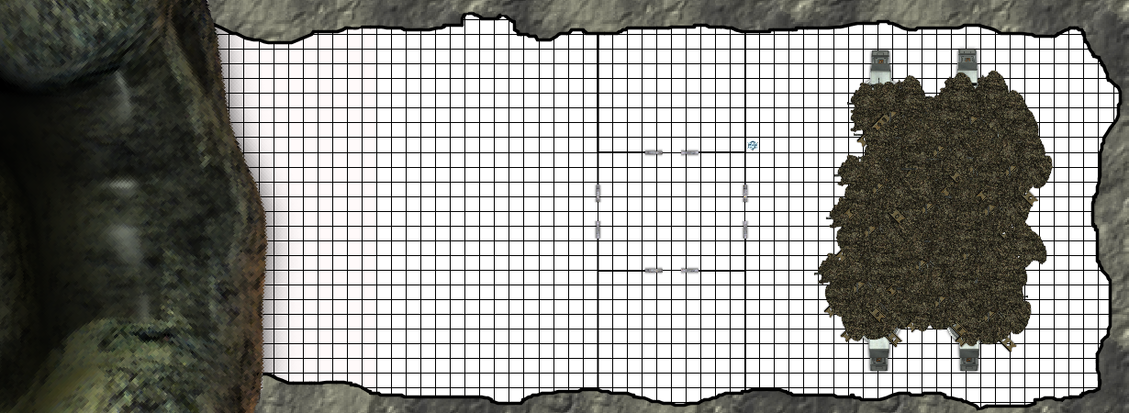
1
2
4
3
5
6
1 Square = 2 meters
Notes on Level 3:
The collapse of the second level and lift shaft caused a partial collapse of the ceiling in the engineering area of the third level. The Eorna subsequently removed the undamaged power reactors and computer equipment and returned it to Volkos. The entire level has been obviously picked through for salvage, although some evidence of the Eorna can been seen in the debris.

1. Secret waterfall entrance
125 meters from the top of the cliff is a cave opening concealed from the outside by the waterfall. It is not easily visible from the air, as the cool water and mist interferes with IR detection devices. Additionally, the waterfall obscures the opening from a distance, but is not so large that it completely blocks it from view. It is visible to characters who are actively searching for it from the pool at the bottom, the top of the cliff, or within 200-300 meters from the air.

The rough entrance is approximately 46 meters wide and 35 meters high. The jetcopter captured from the pirate outpost could land inside the cave provided the pilot does not try to hover under the falling water before the opening. The GM may require a skill check to safely do so.

2. Landing area
The walls and ceiling are rough and vary slightly in dimension, but the floor throughout the level has obviously been made level and flat by some sort of artificial means. There are large scratches in the rock floor throughout this area from the many takeoffs and landings of air and spacecraft in this area. The air inside this area is damp from the mist created by the repeated action of the water against the rock. The GM may elect to have an encounter with some type of mold or slime type of creature.

Party members will see some shattered crystal shards amid the rock, dust and debris on the floor. They may also find bits of tubing and strange wiring of strange metal alloys from the removal of the various pieces of equipment that had once been here.

3. Storage Room
The dust in this room is very thick. It has apparently only been disturbed by small creatures for a long time. Characters may find debris matching the description of area 2, above.

4. Hallway
The doors are all stuck open throughout the level. If the PCs examine them, they show evidence of having been pried open.

5. Storage Room
This room matched the description of area 3, above.

6. Engineering
This large room has suffered a partial collapse. The force of the second level and lift collapse carried into sections of this cavern. The walls of the lift shaft along with all of the supporting structure and power lines going through it collapsed throughout the center of the cavern and took a part of the rock ceiling with it.

The resulting damage destroyed and buried 4 large power reactors. There were other reactors here as well, and characters searching through the area may notice that there was other equipment here that has long since been removed. Bent and torn conduit and shattered crystal shards are throughout the debris area. There is also a damaged crystalline light near the door. It has taken some damage and has several cracks in it.

Parts of the buried reactors can still be seen, and it can also be seen that panels on the equipment have been opened and components removed. A tech character would recognize that the technology is the same as in the first level old, yet advanced. It obviously uses some form of crystalline circuitry.

