ERT

Conversion by Laura Mumma, Tchklinxa
TSR first introduced the Ert in the 1978 Gamma World 1st edition by James M. Ward and Gary Jaquet.

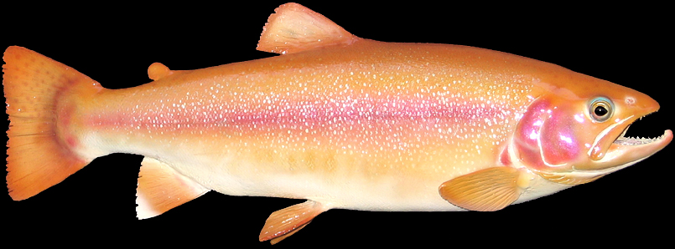
NAME: ERT

TYPE: Small Carnivore
NUMBER: 1
MOVE: Slow NS: 4.8 CS: TS: RS: 24 meters
IM/RS: 5/50
STAMINA: 40
ATTACK: 55
NO. OF ATTACKS: 1
DAMAGE: See Special Attack
SPECIAL ATTACK: Bite, S14/T5! (turn victim to stone)
SPECIAL DEFENSE:
NATIVE WORLD:
HABITAT: Swift flowing Mountain streams.
GENOTYPE: Fish: Trout
MUTATIONS:
DESCRIPTION: This innocuous looking fish, which can be up to 1 meter long, lives in swift flowing mountain streams. It has an awesome defense mechanism. Any creature it manages to bite has a chance of being turned to granite-like rock. (Treat as a poison attack of intensity S14/T5! Unless successfully treated at the end of 5 turns the victim is turned to stone.)

