Arks & Mogs:
Conversion by Laura Mumma, Tchklinxa

The Hunde; a canine like biped alien race; was presented in Star Frontiersman number 19, page 25-26. Referees may wish to review that article to better understand how the Arks can fit in as a dangerous subculture or clan of the Hunde.

Average Stats for Dog-Like biped Mutants (Mogs)
STR/STA: 45/40
DEX/RS: 60/60
Bite 1d10
Heightened sense of smell, heightened hearing, night vision, color blindness.
Average walking movement 10 meters per turn.

"Heaven goes by favor. If it went by merit, you would stay out and your dog would go in." – Mark Twain

Mogs: (The Dogmen)
Type: Medium Carnivore
Number: 1-4
Move: Medium (10 m/t walking, 20 m/t charge, 13 m/t trot, 50 m/t running)
IM/RS: 6/60
Stamina: 40
Attack: 65
# of Attacks: 2
Special Defense: none
Special Attack: none
Damage: Bite 1d10, Brawling +5%
Ability Modifiers (For PCs):
STR/STA +5 DEX/RS +0 INT/LOG -15 PER/LDR +10 personality only
Base Genotype: Dog
Planet of Origin: N/A
Habitat:

Standing usually 2 meters tall the Mog is a biped genetically created, mutated or altered canines for use as companions, servants and protection. Many believe mankind sought to create humanoid dog to be used for companions, servants, body guards or in war, while others believe an accidental mutation amongst canines then was further genetically modified to mankind’s desires. The Mog became a common pet species amongst the humans in the Frontier. The Mog normally lacks the special attacks and abilities of the Ark (unless it was purposefully created to have them, or exposed to a way to gain mutations per Gamma Dawn rules) and is less intelligent than either the Ark or the Hunde. It is however friendly and very loyal to their humans. All Mogs have a heightened sense of smell and heightened hearing. (+10% to tracking, +10% to hear distances but -20% against sonic attacks, Night Vision +10% but no adverse affects during the day, Color Blindness ‐50% to get any color choice correct.)

Mogs INT/LOG scores are generally never over 30 (only PCs can be higher).

How Much For The Mog In The Widow?

The base price for an untrained fixed Mog pup is 1000 credits.
Adult fixed Mogs that are trained to be companions or servants usually go for 2000 to 3000 credits.
Mogs (fixed) trained for protection work or helping the disabled cost a minimum of 4,000 credits.
Breeding Mogs are extremely expensive ranging in price from 5,000 to 10,000+ credits depending on strain, lines, training, show and competition records.

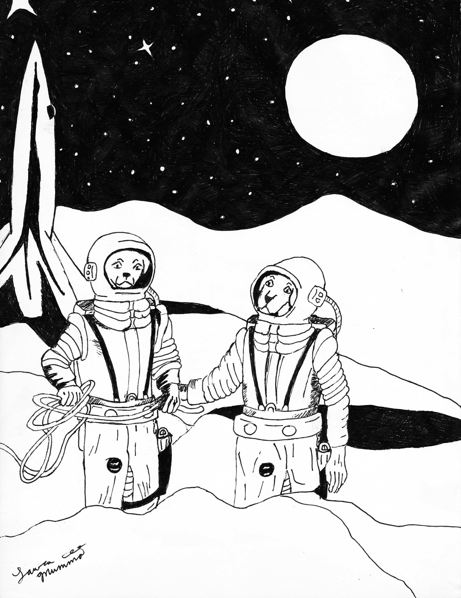

If dog’s knew the nature of a mankind’s heart would they still be our friends?

Ark: (Hound Folk, Dog Folk)
Type: Medium Carnivore
Number: 1-4
Move: Medium (15 m/t walking, 30 m/t charge, 20 m/t trot, 75 m/t running)
IM/RS: 6/60
Stamina: 40
Attack: 65
# of Attacks: 2
Special Defense: Weather Manipulation
Special Attack: Telekinesis, Life Leech
Damage: Bite 2d10, Brawling +15%
Ability Modifiers (For PCs):
STR/STA +15 DEX/RS 0 INT/LOG -5 PER/LDR -10
Base Genotype: Dog
Genetic Stability: Stable
Native World: N/A (referee should decide how/what arns are in their setting)
Habitat: Mountain, Forest, Ruins or Radioactive Zones

The Ark is an intelligent species. Standing between 2 to 3 meters tall the Ark always walks on its well-developed hind legs. It has a mental strength: LOG mental resistance of 46 and radiation resistance: of 20 which allows the Ark to ignore 20 points of radiation intensity (example an Ark exposed to -25/R20 radiation would only experience -5/R20 effect). All Arks have the following mutations: telekinesis, weather manipulation, and life leech. Arks fear large winged creatures (this is a phobia and requires a LOG check with -25 penalty to overcome). They also have heightened sense of smell and heightened hearing. (+10% to tracking, +10% to hear distances but -20% against sonic attacks, Night Vision +10% but no adverse affects during the day, Color Blindness ‐50% to get any color choice correct. Their racial color blindness, causes them to have a very unusual style of coloring. It can hurt the eyes of the other races because they only see in shades. This can lead to confusion when working with art or wiring diagrams of other races.)

History of the Arks:

Arks are the result of project A.R.K-9 (Advanced Research Canine Project), Mog DNA was enhanced with the alien race Hunde DNA and the resulting Mog-Hunde hybrids subjected to unethical experiments by a human run bio-weapon company. They where subjected to horrific experimentation and genetic manipulation in an effort to create a War Mog hybrid. What little is known about this project by Star Law indicates that either Sathar based bio-forming was involved or the Sathar may have influenced the direction of the research.

Arks have floppy ears that many pups parents have cropped at birth, along with the pups tails docked. Though a minority movement has started amongst them to stop such “enslaved” practices, while others insist it is part of their warrior culture and history that must be preserved. Most Arks have a smooth tight coat that is black with tan markings (80%), though they also come in red and tan, blue/grey and tan, fawn and tan, chocolate and tan, brindle and tan, gold/yellow and tan. Arks with other markings or colors are usually the result of Mog or Hunde crossings.

The Ark affected an escape and rebellion from the facility while slaughtering the humans responsible for crimes against them. The leader and lawgiver of the Arks during this rebellion was Karl of Ark X15328 (Ark project experiment litter 15328). Called Karl X by Arks. Karl was incredibly intelligent and led his people to freedom to the wilds of the marginal planet the research station was located on. By the time Star Law became involved in this blight on UPF history the Arks had established themselves on the planet, successfully defending themselves from any attempts to eradicate or capture them. Star Law with the help of the Hunde where able to end hostilities and negotiate a peace treaty with the UPF. The Hunde successfully lobbied for the Arks to be considered a Hunde race as Hunde DNA had been illegally and unethically used to create them and be put under Hunde protection and given rights under UPF law. Star Law and Hunde scientists have been able to prove from the documents and research seized at the time of the rebellion by the Arks and recovered information latter from the now defunct bio-weapon company that Sathar where behind many of the most horrific experiments on the ancestors of the Arks. In short Arks may distrust and have issues with humans but they truly despise Sathar.

Arks have a strong distrust of humans and view all humans with suspicion, many hate humans (-10 when interacting with humans). The only humans allowed on the Ark planet are Star Law as they stopped the efforts of StarGenBio from killing the Arks and actively sought the arrest of StarGenBio Ceos and employees involved in crimes against the Arks and it was Star Law that brought the Hunde in to help the Arks. Arks are fiercely independent, they will very rarely (almost never) take aide from humans, they are more willing to deal with other races. The only races they freely will except aide, assistance or interact with in a very friendly manner are the Hunde or Mogs (+10 when these species interact). Arks are a proud people and believe all Mogs should be freed and helped to become more than the slaves humans have made them into (Arks do understand most Mogs are less intelligent then most Hunde or Arks but strongly feel slavery is preventing the Mogs from developing their true potential).

Ark pups are encouraged to fight each other from a young age (though parents do not allow such brawling to become deadly) so they will never be slaves again. Arks enjoy physical combat sports over “games for children” (the Arks view all non combat sports as children games). Arks are often gruff, aggressive, and impatient with other races. Arks feel they must protect their rights by demonstrating their strength. Arks view themselves as the warriors they where created to be. They see themselves as a race whose duty it is to protect the Hunde and the Mogs from the predatory practices of other races.

Arks acknowledge the Hunde as their kin but feel the Hundes are not doing enough to free the Mogs and stop the exploitation of Mogs. Hunde social workers have been attempting to integrate Arks into their society and the UPF but with little success mainly because of the Ark distrust of humans. Arks do not consider themselves or Mogs dogs and if referred to in anyway as a “dog” they will be greatly offended.

Arks can breed with both Mogs and Hundes and produce viable offspring, note however the pups only have a 50% of inheriting any of the Ark’s parents special abilities, or size. In addition there is a 10% chance the pups of such a mating will have unique physical or mental mutation.

In the apocalyptic or primitive setting Arks carry wicker shields and large clubs as weapons. (They use stone spears, knives and do wear leather or studded armor.) They are more than capable of having more advanced weaponry. Arks have a unique range weapon they created that uses compressed air called the Gow Gow. In addition they have a tradition of capping their teeth to protect the teeth in battle.

They do have a history of hunting other sentient species for food. They consider human hands to be a great delicacy. This taste for human goes back to their rebellion days when there was limited food and the enemy forces where often the only food available.

Arks in space should be treated as the intelligent and potentially deadly foes they can and should be. As a species they do consider it slavery for any sentient being to keep a genetically modified or mutated dog that can walk up right as a pet or to do various duties as a servant. They will see euthanasia and the sterilization of such beings as murder and genocide. Arks feel any human that keeps a Mog for any reason is a slaver.

Regardless of how the Ark best fits into a setting they will have a society structured on the complexities of the canine pack and that focuses on the hunt. Arks are loyal to the ones they love or causes they love. Arks form packs based on common needs or interests as well as extended family units.

Telekinesis (SL1-6): The Ark is able to move objects up to 15 meters away, plus 5 meters for every SL point, with his mind. The STR that he uses to lift the object is equal to 20xSL. The Ark can use telekinesis for 9 turns, then he must rest 9 turns, before again using the power. Telekinesis cannot be used for fine manipulations, like a hand operating a machine. It can only lift, carry, move, throw or rotate an object. It cannot wield a weapon, except for throwing big heavy things. Lifting and carrying objects telekinetically is just as fatiguing as carrying them physically. The character cannot lift himself. Any attempt to lift a creature requires a mental attack. The same is true for attempting to manipulate an object in someone's hands. An Ark that is using this mutation, even just to hold an object cannot attack unless he is allowed multiple actions per round.

Weather Manipulation: This allows the Ark to manipulate the weather in the area he is in. The newly created weather conditions will last as long as the mutant concentrates on them. (Note that if the mutant is hit in combat his concentration will be broken.) The mutant must concentrate for a full minute (10 turns) before the weather begins to change, and it takes another 2 minutes (20 turns) for change to be completed. The weather will be affected in a 10-kilometer radius around the mutant. The weather cannot be radically changed, i.e. from below zero to 100-degree heat wave. The extent of manipulation possible depends upon the prevailing conditions.

Aspect of Weather | Prevailing Conditions | Possible Change
^{Cloud Cover} | ^{Clear} | ^{Very Clear}
^{Precipitation} |  | ^{Partly Cloudy/Hazy}
 | ^{Partly Cloudy} | ^{Clear}
 |  | ^{Cloudy}
 |  | Misty/Light Rain/ Light Snow/ Sleet/Small Hail
 | ^{Cloudy} | ^{Partly Cloudy}
 |  | ^{Deep Clouds}
 |  | ^{Fog/Heavy Rains}
 |  | Heavy Snow/Driving Sleet/ Large Hail
^{Temperature} | ^{Hot} | ^{Sweltering Heat}
 |  | ^{Warm}
 | ^{Warm} | ^{Hot}
 |  | ^{Cool}
 | ^{Cool} | ^{Warm}
 |  | ^{Cold}
 | ^{Cold} | ^{Cool}
 |  | ^{Arctic Cold}
^{Wind} | ^{Calm} | ^{Dead Calm}
 |  | ^{Light Wind}
 | ^{Light Wind} | ^{Calm}
 |  | ^{Strong Wind}
 | ^{Strong Wind} | ^{Light Wind}
 |  | ^{Gale}
 | ^{Gale} | ^{Strong Wind}
 |  | ^{Storm}
 | ^{Storm} | ^{Gale}
 |  | ^{Hurricane/Typhoon}

All three aspects of the weather can be manipulated, but only as shown: For example, a day which is clear and warm with a light wind can become hazy, hot, calm day. Contradictions are not possible, fog and strong wind, for example. Success is not automatic SL above 1 increases the % chance by +5: There is a base 65% chance of causing one of the possible changes. If it is desirable to cause a change one degree away (from clear to light rains, for example) the chance of success drops to 35%, and double the time is required (20 turns of initial concentration, 40 turns to accomplish the change). If a change two degrees away from prevailing conditions is desired (such as warm to arctic cold, the chance of success is only 10% and triple the time is required (30 and 60 turns). The percentile dice are rolled after the initial concentration is completed, but the new conditions are not fully effective until the change in weather is completed. If the mutant is unsuccessful in changing the weather (either through failing the percentage roll or being interrupted after the initial concentration), he must rest a full week before attempting weather manipulation again. This mutation is usable a maximum of once per day.
Life Leach: The mutant is able to drain the life force from all semi-intelligent or intelligent beings, friend and foe alike, within a 10 meter radius of the mutant. Small animals and normal plants are not affected by life leech. Most common animals over half a meter in size qualify. Plants only qualify if the are mobile or sentient. The character drains 2xSL STA points from all such creatures within 10 meters each round. He can continue to use this power for 5+SL rounds, but then must rest it for at least 20 hours. Range increases by 3 meters for each SL over level 1. The STA points drained from nearby creatures are first used to heal any damage he has taken. Any leftover points are put into a special pool of STA points. All subsequent attacks do damage to this STA point pool. Only when the pool is empty do attacks affect the creature's original STA points. After four hours, what remains of any of these "phantom" STA points in the pool begin to fade at the rate of 5 per round. The STA pool cannot exceed the character's SL x 10.

Gaming History of the Ark:
TSR first introduced the Ark in the 1978 Gamma World 1st edition by James M. Ward and Gary Jaquet. In the original setting of Gamma World arks where clearly meant to be one of many dangerous intelligent species that might not just kill the players but eat them. As Gamma World developed and changed many folks have actually used them as a player race option. Arks in Star Frontiers offer some interesting possibilities. The Arks here have been presented as the result of purposeful genetic modification of man’s best friend and an alien race that went wrong or went too right depending on the goals of the scientists. Arks could have equally come into existence on one of the quarantined planets, the accidental mutated descendents of pet dogs now hunting the survivors of the blue plague. It is possible that the colony ships the Morden or the Warden is the origin of the Arks or even the Hundes in space. The Gamma World timeline that includes these Metamorphous Alpha ships was published in Dragon 88 (August 1984) “Before the Dark Years” by James Ward and Roger Moore.

References:

Gamma World, by James M. Ward and Gary Jaquet, 1978, TSR Rules,

Gamma Dawn, by Mr. Scott Ireland and Bill Logan, 2007

Spaceballs, 1987 movie, co-written by Mel Brooks, Thomas Meehan & Ronny Graham

Star Frontiers, by TSR Staff, editing by Steve Winter, 1980, TSR

Dragon #88 Volume IX, Number 3, August 1984 “Before the Dark Years” by James M. Ward and Roger P. Moore

Star Frontiersman issue 19, page 25-26 “Hunde” by Willian Douglass.

